Crystallographic Reality Documentation
  - This document outlines the processes that have been used during the development of the VR software Crystallographic Reality.

Contents
Contents 1
Initial setup 1
Installing Unity 1
Creating the project 2
Setting up the project for VR 2
Old unit cell and symmetry setup (but still useful) 7
Creating atoms 7
Adding unit cells using C# scripts 7
Additional Updates 9
Creating symmetry (Hermann-Mauguin) 10
Creating a user-menu for loading crystals 11
Loading Crystal with symmetries 13
Getting the info from the .cif-file 13
Identifying symmetries 14
Placing atoms 16
Visualizing symmetries 18
Finalizing project 19
Additional updates 19
Updating Unity 19
Changing settings during runtime 19
Scaling player 20
Building Game 20
File dialog 21
Building the project (again) 23

Initial setup
Note: The software was developed on a 64-bit Windows 10 computer.

Installing Unity
- Install Unity Hub. I signed up for a personal account on https://unity.com/ and downloaded UnityHubSetup.exe from there.
- Once Unity Hub is installed, you need to install an actual version of Unity. Go to Installs and select Add. Here I picked the recommended version at the time, Unity 2020.3.11f1 (LTS).
- After selecting version, you will be asked to pick Dev tools, Platforms, Documentation, and Language packs. Here I picked the following:
Dev tools: Microsoft Visual Studio Community 2019. This will be the program where the C#-scripts are written.
Platforms: Android build support, with Android SDK & NDK Tools and OpenJDK. This is not needed for SteamVR headsets, but I wanted to be able to export the program to a standalone headset (Oculus Quest 2). This can also be of use if the Department invests in standalone headsets.
Read and accept the License term, then Unity hub will begin installing your version of Unity.

Creating the project
- Go to Unity Hub’s Projects tab and select new (If you have multiple versions installed, select the version we made previously).
- Pick template, then enter name and save location. I have seen a tutorial selecting Universal Render Pipeline, but that was before the VR template was made, and so I will pick the template VR, which needs to be downloaded. Press download, then install, to install the template. I picked the (temporary?) name Crystallographic Reality and chose to save it in my GitHub repository.
- Finally, click Install. This will begin the process of setting up the project and might take a few minutes.

Setting up the project for VR
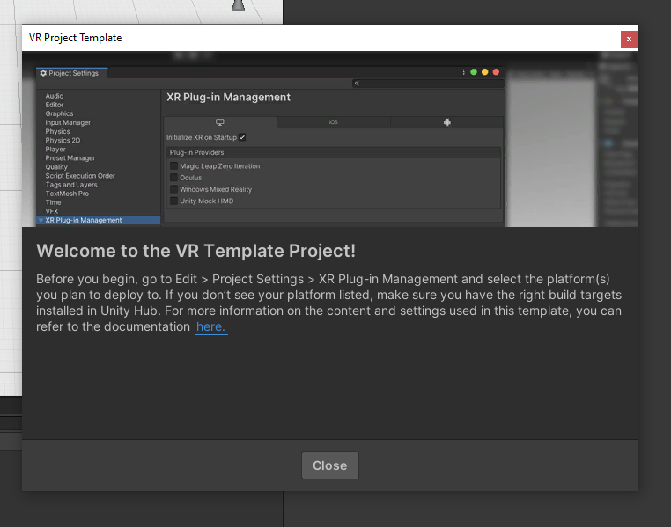
- A welcome message (Figure 1) pops up when the project is installed and has started, telling us to enable XR Plug-In Management and select the platform(s) we wish to develop for. Select Project Settings on the drop-down menu Edit to the top right.
From there we select XR Plug-In Management. We want to develop the software for OpenXR (SteamVR), and mark that off, and Unity will install the necessary packages.
Figure 1 - Welcome message after installation and project start-up.
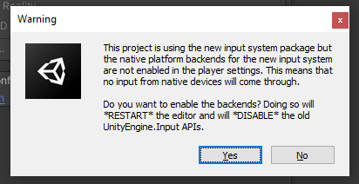
- After the installation I received the warning to the right (Figure 2):
Not having native input sounds bad (controllers will likely not work) and so I press Yes. After installing the Editor then restarts, as the warning message said.
Figure 2 - Waring about enabling backends for the new input system (the Open XR system).
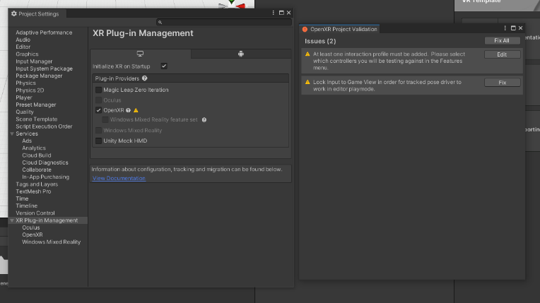
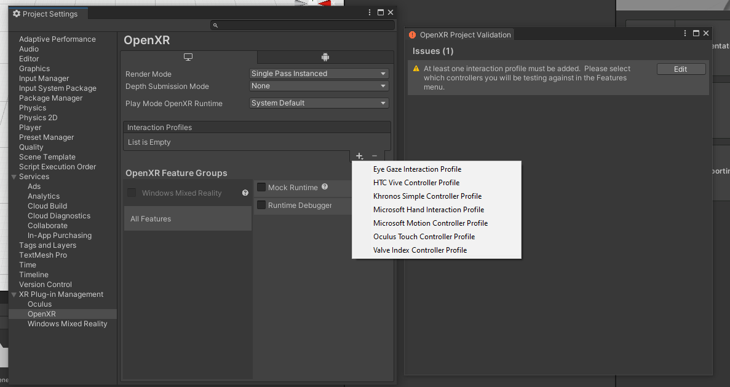
- After restarting we can see that OpenXR is enabled, but there is a warning symbol next to it. By clicking it, we get a pop-up window (Figure 3) that explains the current issues.
The second issue (Lock Input to Game View…) is solved simply by pressing Fix.
On the first issue we press Edit and are taken to the sub-menu OpenXR to select which controllers we will be testing against. Under Interaction Profiles we see the list is empty, and we add the headsets we wish to be functioning (Figure 4).
Sissel spoke of HTC, and so we add the HTC Vive Controller Profile. This solves the issue. In addition, I add Valve Index and Oculus Touch as they are popular headsets as well. I need Oculus Touch for my own headset during development.
Figure 3 - OpenXR issues after enabling.
Figure 4 - Interaction Profiles.
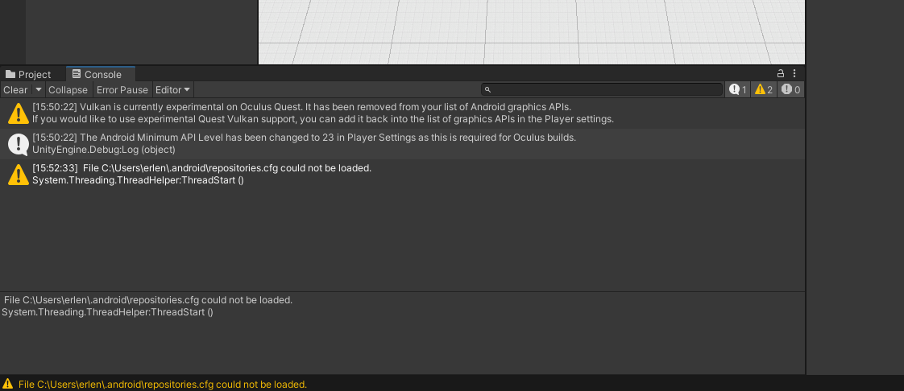
- I want the software to work on standalone android headsets, and as such I go back to the main XR Plug-In Management menu, then to the tab with the Android image, and mark off Oculus.
On the bottom of the window I saw a message, but as it concerns Android (aka. not out main development platform) I leave it alone (Figure 5).
I re-launched the project, and the issue disappeared.
Figure 5 - Console warning message after enabling Android -> Oculus support.
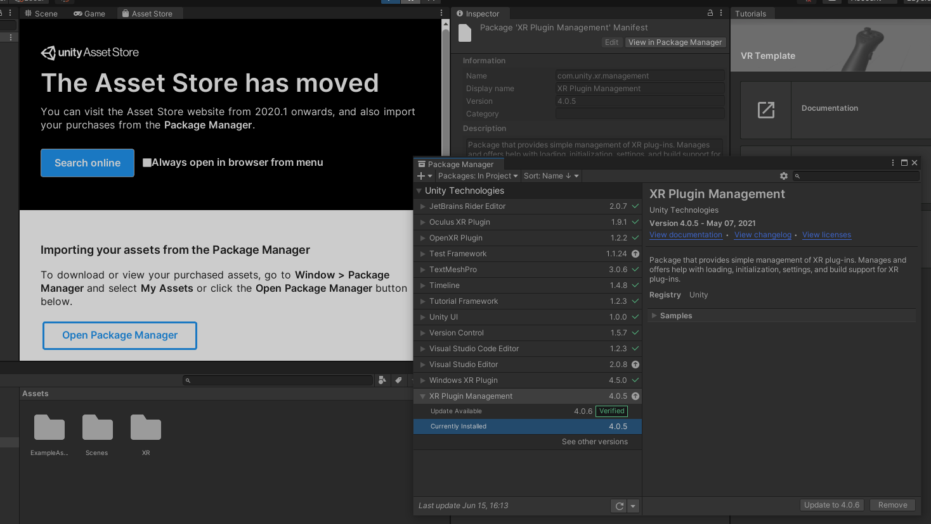
- In an attempt to add hands, I looked at the Package Manager. In this case, this was done by pressing Asset Store over the Scene window, then selecting Open Package Manager. I was looking to see if I had any installed assets, but instead saw there were some packages that had updates available. These were then installed (Figure 6).
XR Plug-In Management was updated from 4.0.5 to 4.0.6.
Visual Studio Editor was updated from 2.0.8 to 2.0.9.
Test Framework was updated from 1.1.24 to 1.1.26.
Later on I saw a new update for Test Framework, and updated it to 1.1.27.
Figure 6 - Package Manager with updates as upwards facing arrows.
- In the Project tab I went into the Assets folder and made folders called “Prefabs”, “Materials” and “Scripts”.
- I went to the Asset Store online, and searched for VR Hands and filtered to free. There I found the SteamVR Plugin, which is developed by Valve, and handles 3d models for controllers, input from the controllers, and estimating what the hand looks like while using the controllers. This seems promising, and while I did not install it. It could be later. https://assetstore.unity.com/packages/tools/integration/steamvr-plugin-32647
- Before continuing I wanted to make sure that the XRRig that was automatically made during setup worked. As my setup consists of an Oculus Quest 2 connected to PC by Virtual Desktop, I needed to find a way for this to work. After searching the web I found a promising guide (https://forum.unity.com/threads/unity-editor-and-virtual-desktop.881449/).
  - Launch Virtual Desktop on the PC.
  - Launch Virtual Desktop on the Quest 2.
  - Execute the following command in cmd, substituting for personal file locations:
"C:\Program Files\Virtual Desktop Streamer\VirtualDesktop.Streamer.exe" "C:\Program Files\Unity\Hub\Editor\2020.3.11f1\Editor\Unity.exe" -projectpath "\"C:\Users\erlen\Documents\Github\Crystallographic-Reality\Crystallographic Reality\" -cloudEnvironment"
(\” after -projectpath the string is parsed as an argument to VRDesktop, then to Unity, so white spaces causes issues without \”).
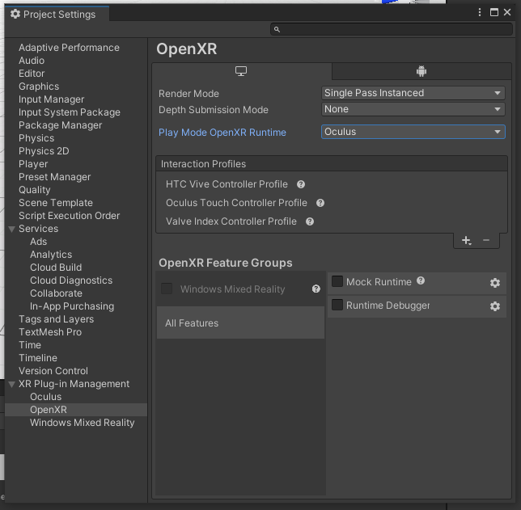
  - The steps above did not work, likely as Oculus is not enabled for desktop development. Under OpenXR I chose Oculus as the Play Mode OpenXR Runtime to see if that made a difference (Figure 7).
It did not work, but changing to Play mode OpenXR Runtime to SteamVR fixed it. We now have a functioning XRRig for our software!
This is only relevant for my own development on Quest 2, but is still useful to have written down somewhere.
Figure 7 - OpenXR settings for XR Plug-In Management.
  - The command actually seems redundant, but every time I launch the project the Play Mode is set back to “System Default”, and I have to change it before testing.
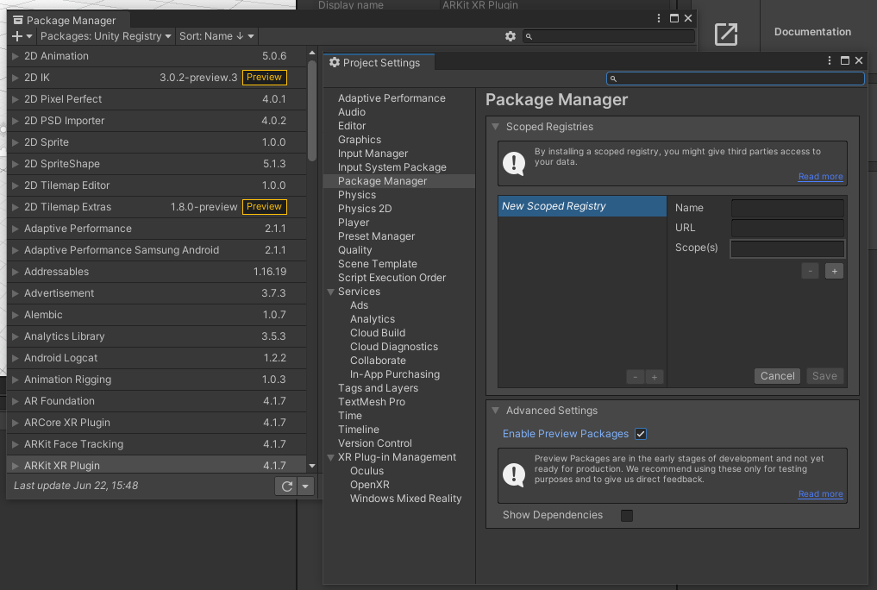
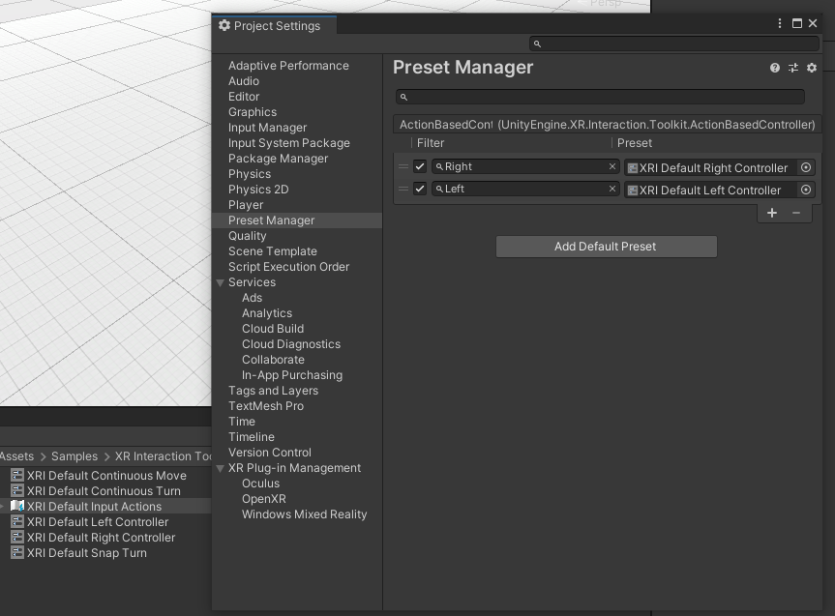
- We can now walk around in VR, but there are no controls set up yet. We return to the Package Manager (Window->Packager Manager). Here we filter Packages from In Project to Unity Registry. We now click the settings wheel and Advanced Project Settings. We now Enable Preview Packages (Figure 8), and click on I Understand on the pop-up. Keep the Advanced Project Settings window open.
We scroll down to XR Interaction Toolkit and press install. Now, to get som default controls, we press the drop-down on this XR Interaction Toolkit and Import the Default Input Actions. These are not in our project, but not on our controllers. Do do this, we go to our Project folders and enter the new folder Samples->XR Interaction Toolkit->1.0.0-pre.4->Default Input Actions. Here we should see some things called XRI Default… . We select XRI Default Left Controller, and in the inspector at the top, press Add to ActionBasedController default. We do the same for the Right Controller.
Now we return to the Advanced Project Settings window and go to Preset Manager. Here we name the Left and Right controllers respectively, so we can tell them apart (Figure 9).
From here we go to our Hierarchy and delete the previous XRRig if it already exists (I had one as I used the VR template when I made the project). We right-click and Create->XR->XR Rig (Action-based). Finally, we go to our XR Rig, press Add Component and search Input Action Manager. Change the Action Assets to 1, and add the XRI Default Input Actions.
Figure 8 - Package Manager and Project Settings.
Figure 9 - Advanced Project Settings.
- When running this, we are missing controllers, and have red lines which show where we are pointing. Sad to lose the controllers, but this can be fiddled around with later. We started far above the floor, so I selected the XR Rig in the Hierarchy and in the Inspector I changed the Tracking Origin Mode to Device. This didn’t *really* work, but will help later. I changed the Position of the XR Rig to (0, 0, 0), which fixed the issue. The campera Y offset was left at its default (1.36144).
These “red lines” can be customized for color, thickness, color activation and more in Unity.
The tracking origin mode was later changed to “Floor”.

Old unit cell and symmetry setup (but still useful)

Creating atoms
- In the Hierarchy I right-clicked to create a 3D object -> Sphere, and placed it at (0, 0, 0) (y-coordinate is height, while xz is the horizontal plane) using the Transform component in the Inspector. I renamed it to “Atom”. In the inspector I also added a component called Rigidbody, which gives the atom physics. This made me realize the XR Rig was facing along the z-axis, so I rotated the XR Rig by 90 degrees in the y-direction, by clicking XR Rig in the Hierarchy then in the Transform component in the Inspector changing the rotation in y to 90.
- I dragged this atom from the Hierarchy into the Prefabs folder in the project. Dragging the object into the folder made it a prefab, so when I edit the prefab, any and all atoms I create from the prefab will be changed as well.
- In the RigidBody I un-checked use gravity, to keep it standing still. Then I opened up constraints and checked off Freeze Position and Freeze Rotation for all axes.
- I then deleted the Atom GameObject for now.
  - Colors, shades, and possibly sizes will be changed later. This might incorporate a dictionary that fits the material to the atom it will represent.

Adding unit cells using C# scripts
- I downloaded cif2cell with pip install cif2cell.
This installed PyCifrW-4.4 and cif2cell-2.0.0a3. As there seemed to be some issues with launching the program, it was installed once to the “standard” location, and once to the GitHub repository, for easier access to the cif2cell file, the sample .cifs and more.
- After fiddling a fair bit with cif2cell I soon understood that it would be complicated to find a fitting file format from cif2cell to then read and import to Unity with a C# script. I therefore proceeded to figure out a way to create a unit cell from a script so that part was up and running.
  - I created an Empty Object in the Hierarchy and named it “Crystal” and put it in the coordinate (1, 1, -0.5) in the Inspector’s Transform. In the Hierarchy I then moved our previous Atom into it to make it a Child of the Crystal. The “Crystal” was later moved to (0,0,0) as the script will set its position.
  - In the previously made Scripts folder I right-clicked to Create a C# script which I named “Crystal”. I then dragged it onto the Empty Game Object “Crystal”. Now our script is a component of this game object.
  - In this file Crystal.cs (c-sharp) I made a Read function to read the file I want to construct the unit cell/crystal. For now this simply outputs each line in the Unity Console.
  - I created a reference in the script to our Atom prefab. I declared a GameObject called Atom in the script, then in Unity I dragged the Atom prefab onto this in the Inspector of the Crystal.
  - When the atom was instantiated, it used the world position and was not a child of the Crystal GameObject. This was addressed by declaring a GameObject called crystal, dragging our Crystal Object onto this in Unity, then making this the atom’s parent.
  - During programming I realized Visual Studio was not correcting Unity errors. I went to Unity -> Edit -> Preferences -> External Tools -> External Script Editor, and chose Visual Studio, before restarting Visual Studio. This fixed the issue.
  - I set up each of Silicon’s atom positions manually.
  - Stuff was and is being done without specifying here. Anything script-related will be commented in the script, and when scripts are added enabled, they will be explained.
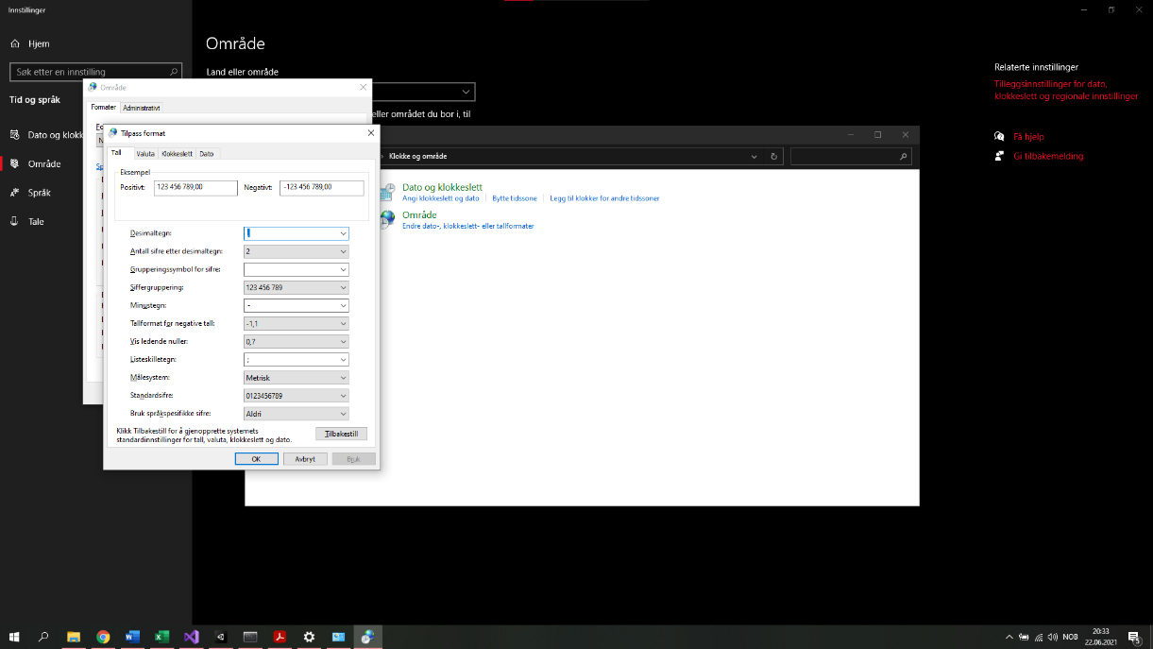
  - During programming I came across an issue with converting strings to numbers.
NOTE! This does not fix the issue. I have, however, kept it in the document, in case it becomes useful.
This came from Norway using (,) comma as a decimal separator. I managed to find a way to change this to (.) period, so Visual Studio would work. I typed Område in the search box, then entered Områdeinstillinger. In windows 10 settings top right I pressed Tilleggsinstillinger for dato, klokkeslett og regionale instillinger. This opened the old control panel, where I pressed Endre dato-, klokkeslett- eller tallformater. This opened a small window where I pressed Flere instillinger…. Here I could set the decimal separator to (.) period. See (Figure 10). Appearently this did NOT fix the issue. However, I know that is the issue as it is solved when using comma, but crashes when using period.
The issue was finally fixed by applying Globallization with “InvariantCulture” in the C#-script, allowing the program to itself convert commas and periods as needed.
Figure 10 - How to change Norway's decimal separator in Windows 10.
- For adding a unit cell, the following functions were made and used:
  - ConvertCiftoXYZ() was made to run the cif2cell command, and save info cif2cell did not include in .xyz (namely cell_length, cell_angle, and symmetry_H-M.
  - ReadXYZ() read our newly made .xyz-file, taking the atomic positions, and elements and saved them to arrays.
  - CreateCell() took these arrays and Instantiated the Atom prefab for each atomic position, while also duplicating atoms in corners, edges and sides, to get a complete cell. It also applies a color to the atom based on its element.

Additional Updates
Updated Unity Hub to 2.4.4
XR Plugin Management 4.0.6->4.0.7
Visual Studio Editor 2.0.9->2.0.11
OpenXR Plugin 1.2.2->1.2.3 (This lead to a one-time crash when launching, but Unity devs are aware, and the issue has not re-occurred)
For now, I have *not* installed new versions of Unity itself.

Creating symmetry (Hermann-Mauguin)
- For adding symmetry, we fetch the Hermann-Mauguin symbol from the .cif-file, and make an algorithm to determine what each symbol is. This algorithm is part of the function AddSymmetry().
- Initially seeming easy, I quickly realized that I would need to adjust the algorithm based on the crystal system (an orthorhombic system indexes the symbols differently than e.g. a cubic system.
  - A separate function for creating a visible mirror plane was created, named CreatePlane(). The function takes in a 4-dimensional array of vectors, being each of the four corners of the plane. It also takes in a color, to set the plane’s color. Lastly it takes in a name for the plane, which defaults to “Plane”, and a parent for the plane. The name is mostly useful for development as it becomes easier to separate each plane in the Unity editor later. The parent of the plane, however, is needed as this allows the plane to move along with its parent object, which will likely be a child of the crystal itself. If the plane has no parent, when the crystal is moved of changed in any way, the plane will not change, and that means e.g. mirror planes suddenly face the incorrect directions
- Hermann-Mauguin gives only the symmetries necessary to derive all other symmetries, and so I would need to combine each symmetry manually, and this is a large undertaking.
Being such big job, the Hermann-Mauguin method will be abandoned, and in place I will read each symmetry matrix from cif2cell.
I will need an algorithm to couple each matrix to a type of symmetry operation, and this will be based on determinants, counting negative signs, and comparing matrix elements to set sin() and cos() values, among possible other methods.
Once the algorithm is up, the matrices can take the place of ReadXYZ() and we could simply use the basic coordinates in the .cif-file, leading us to only need cif2cell for the symmetry matrices.
The algorithm should also generate visual symmetries in the crystal (say a visible mirror plane, or screw axis), and hopefully connect the different atoms together by tagging them with the appropriate symmetries.

Creating a user-menu for loading crystals
As it stands right now, the script reads a set file and creates the cell upon startup. Everything hinges on the Crystal C#-script, and it all lies in the MainGameScene, which is made by Unity.
To make the program work for general use, we need a way for the user to select a file upon startup, and possibly some parameters to change, then once those are confirmed, to generate the cell and its symmetries.
The plan to achieve this is to make a separate scene in Unity where there is a floating UI menu.
I found the following video to use as a guide: https://www.youtube.com/watch?v=BZt74PVb7sM.
- In Unity, go to the project explorer, navigate to the folder “Scenes” and right-click, select Create and make a new Scene. For now, we name this “Menu”.
- Right-click the scene and select Open. Our “MainGameScene” disappears from the Hierarchy and Scene view. Right now, it only contains a Main Camera and a Directional Light.
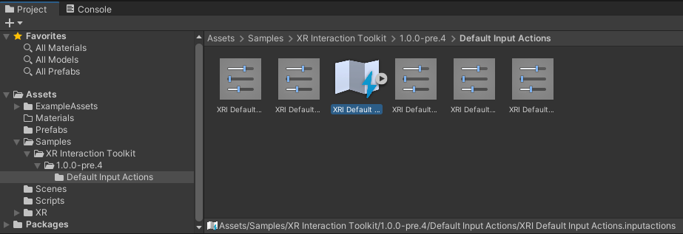
- We begin by creating an XR Rig for our player. The necessary setup for this has been described in Setting up the project for VR, so we simply right-click in the Hierarchy and click XR->XR Rig (Action-based), then right-click the XR Rig and add the component “Input Action Manager”. We then drag our default actions over Action Assets in the XR Rig Inspector. The default actions are located in the project explorer and is in Samples -> XR Interaction Toolkit -> 1.0.0-pre.4 -> Default Input Actions -> XRI Default Input Actions.inputactions (Figure 11).
Figure 11 - Location of Default Input Actions.
  - Our Hierachy now contains a Directional Light, an XR Interaction Manager and our XR Rig. The camera dissapeared when adding the XR Rig.
  - We also move our XR Rig and our XR Interaction Manager objects to 0,0,0 just so they are in an easy position.
- Now we come to creating our menu! We right-click in the Hierarchy and create a Canvas. Click UI -> Canvas.
  - This Canvas is firstly huge compared to our world. We look at the RenderMode in the inspector. Screen Space – Overlay creates an overlay of the menu on top of the scene, and works well for non-VR games. Screen Space – Camerea makes the menu follow us when we turn around, and while this makes sure the player can see it, that seems obnoxious, though useful for a HUD. We therefore select World Space, which makes the menu a GameObject like any other in the world. This will be like having a menu screen on your house wall, and is generally what VR games use.
  - World Space needs an Event Camera, and we drag our Main Camera onto this from the hierarchy. The Main Camera lies in XR Rig -> Camera Offset.
  - You might have noticed that when creating the Canvas we also got an object called Event System. This we can just move up in the hierarchy so its out of the way.
  - The canvas is still huge, so we scale X and Y down to 0.002, and move the position to around x=0, y=1.36144 (matching the XR Rig’s default “Camera Y Offset) and z=2.5, so its easier to see for both us and the player.
- For now we can leave the canvas floating in the world. If we want to make a complete room (for example to show off rotating bravais lattices) we can do that later, we just need to remember to keep the x and y scale the same to avoid distortion. The Width and Height can be adjusted to work with our desired backdrop.
- Let us now make some UI elements for the menu! In the Hierarchy we right-click, go to UI and add Text.
  - We can adjust the text room using it Width and Height. We can change the size of the text with Font Size (using Scale causes blurring). The text is moved to a fitting place on the wall and adjusted so it is visible. Our text is facing the correct way, but if yours is not, rotate the canvas by 180 degrees in Y to fix that.
- To enable interaction with the canvas, we add the component Tracked Device Graphics Raycaster to the Canvas.
  - In the EventSystem we delete the Standalone Input Module and replace it with an XRUI Input Module.
- In an attempt to a way to select a .cif-file I began making a script for the button. It should be placed on the On Click() part in the Button’s component. When clicked a file explorer window should open, allowing the user to navigate to the file they want to load, and the filename should be updated as the Button’s placeholder text.
  - We add component new script to the Button and name it ButtonHandler. The script appears in the project explorer and we move it to the Scripts folder.
  - After editing the script we return to the button and go to On Click(). There we press +, and drag our button object onto the target. On the dropdown we select FileButton and look for our function, here named GetInfile().
  - Preview-running the game this works great, using the mouse to click.
  - Before testing we add a button to switch scene to the MainGameScene. We apply the same script and add a function for loading a different scene.
- In order to keep the file across these two scenes there are different solutions. I went with making a static class to contain such information. I create a Script and call it CrystalManager, where I keep a static string called infile.
- When running now, we can fetch a file, but when launching we get the error that Scene 'MainGameScene' couldn't be loaded because it has not been added to the build settings or the AssetBundle has not been loaded.
To add a scene to the build settings use the menu File->Build Settings...
  - We go to the build settings and click “Add Open Scenes”. This adds the Menu, but not the MainGameScene, so we switch to that and add it as well. We return to Menu and press play again. We select Si.cif, and press launch.
Our scene switched to the MainGameScene and there we had the visualized Si-crystal!
- Some bug-fixing later and our cif2cell-converted files now lie in the persistent datapath, which is in AppData/LocalLow/UiO TeamVR/, and can fetch the .cif from any (available) directory on the pc. Be aware that cif2cell’s licence does not allow incorporating it into proprietary programs. However, I seem to need cif2cell’s main file in the working directory. Therefore, I have added it into Assets->Scripts. The Crystal Script copies it from there into the persistent datapath.
NOTE: Currently the File Dialog is the system’s default one, aka. not in VR. The player will have to remove their headset to choose the file. This could maybe be remedied by using this as a file browser, or another runtime file browser.
- .cif-files can have virtually any name, and sometimes the name is so short the button seems excessively large, or to long for the button to fit the text.
  - We add two new components. 1: Horizontal Layout Group, and 2: Content Size Fitter.
  - We set the Horizontal Layout Group to check Control Child Size for Width and Height, and uncheck Child Force Expand. We also add some padding so the button has more space. Left and Right gets 30, and Top and Bottom gets 10.
  - In the Content Size fitter, we set the Horizontal and Vertical Fit to Preferred Size.
The text font size is 50.
- We need to confirm that python is installed, along with cif2cell. We therefore create another function TestSetup() which will test both that python is installed and that cif2cell is installed, in addition to storing the path to cif2cell for use in the command. This function is not fully completed, as I need a way to get python’s paths and search the paths for cif2cell. It should be fairly easy to implement later, however.
The function shall also make sure required directories exist.

Loading Crystal with symmetries
Our first attempt at making unit cells relied on converting .cifs to .xyz using cif2cell. From there we loaded in the atoms and using a brute-force algorithm we copied atoms on corners, edges and faces to the symmetrically equal other corners, edges and faces.
After having a unit cell we returned to symmetries by taking the Hermann-Mauguin notation and attempting to reconstruct the basic symmetries from there.

Getting the info from the .cif-file
The new method will still use cif2cell, but will instead call it without a conversion filetype. This leads to cif2cell outputting the information straight to the command window. We add the following flags:
- --no-reduce
  - This causes cif2cell to construct the conventional cell instead of the primitive one. More importantly it means that space group symmetries will be included, and not just point group symmetries. This comes in later
- --cartesian
  - Cif2cell will generate output in cartesian coordinates instead of lattice coordinates. (Note: This does not seem to apply for symmetry translation)
- --print-symmetry-operations
  - The command line will include lines of 12 numbers, the first 9 being for the transformation matrix and the last 3 for translation.
We could also have used –print-seitz-matrices, however, the command line print formatting was more problematic as it didn’t have linebreaks between operations
- We create a function ConvertCIF(infile) which takes our .cif-file as input. We create the function as a public static in our CrystalManager script. ConvertCIF(infile) runs our cif2cell command which now looks like this:
cd [PathToInfile] & python [PathTocif2cell]/cif2cell [infile] –no-reduce –cartesian –print-symmetry-operations > [AppdataFolder]/[infile].txt
  - The reason we cd to the infile path is because cif2cell cannot parse inputfiles that lie in a different folder than the working directory
  - We also have included a path to cif2cell. This is due to cif2cell needing to be present in the working directory. A workaround for this is getting the exact path of where the cif2cell-file is stored
  - Supercells can be adjusted for later, by duplicating the unit cell and translating the duplicate to its new position.
- Next we make a function ReadConvert() It iterates over each line in our converted cif-file, looking for the information we want to extract
  - The keyword “Lattice parameters:” leads it to cellLength and cellAngle, where we fetch the… well… lattice parameters.
  - The keyword “Representative sites :” leads it to the mathematical sites in the lattice and their corresponding elements. This gives atomElement and atomPos.
  - The keyword “Operation “ precedes each symmetry operation’s matrix, so we use this to collect each symmetry operation.
  - We can also collect other information such as Space Group number, symbols, bravais lattice vectors and more

Identifying symmetries
We run our symmetry operations through a function called “EvalSymmetry()” for evaluating symmetry.
- Firstly, it det(ermines) the determinant of each matrix, and from there divides it into identity and rotation for positive determinants (det(M)=1), and inversion and reflection for negative determinants (det(M)=-1).
- It then looks at the Trace of the matrix and its non-diagonal components. If the trace is 3 (-3) and there are not non-diagonal components we have Identity (Inversion).
- Next it investigates the rotation / reflection. Let’s look at rotation first.
  - The matrix for rotation axes are given as follows:
$\left(\begin{matrix}1 & 0 & 0 \\ 0 & \cos\left(θ\right) & -\sin\left(θ\right) \\ 0 & \sin\left(θ\right) & \cos\left(θ\right)\end{matrix}\right)$ for a rotation around the x-axis,
$\left(\begin{matrix}\cos\left(θ\right) & 0 & -\sin\left(θ\right) \\ 0 & 1 & 0 \\ \sin\left(θ\right) & 0 & \cos\left(θ\right)\end{matrix}\right)$ for a rotation around the y-axis and
$\left(\begin{matrix}\cos\left(θ\right) & -\sin\left(θ\right) & 0 \\ \sin\left(θ\right) & \cos\left(θ\right) & 0 \\ 0 & 0 & 1\end{matrix}\right)$ for a rotation around the z-axis.
$\left|θ\right|∈\left\{60, 90, 120,180\right\}⇒\cos\left(θ\right)∈\left\{0.5, 0,-0.5,-1\right\}$. This shows us that a rotation along any of the axis directions only has one diagonal component equal to +1. We use this to determine which of the three axis is being rotated around.
NOTE: This causes issues for rotations axes are not parallel to the axis direction. No fix has been implemented as of yet.
  - Now that we know what axis the rotation matrix revolves around, we also know where sin and cos are. We insert perform $\operatorname{atan}\left(\frac{\sin\left(θ\right)}{\cos\left(θ\right)}\right)$ to find the angle $θ$ given in an interval between -180, and 180 degrees. Comparing the angle to known degrees for the different degrees of rotation, we can deduce whether it is 2, 3, 4, or 6. I also added -2, -3, -4, and -6 as one matrix returned $θ=-90$. This might be incorrect to do.
  - After finding the degree of rotation we look at the translation part to see if it is a rotation or a screw. We check if all translation part components are equal to 0. If they are, we have a rotation and are done. If not, we have screw and continue.
  - Here we use the equation for the translation part: $translation=\frac{m}{n}$, where n is the degree of rotation, m is the subscript, and translation is how far the atom moves. The equation is flipped to $m=translation×n$, and we compare m to 1, 2, 3, 4, and 5, to determine the subscript. This should make a 2-fold screw axis into $2_{1}$, and 3-fold into $3_{1}$ or $3_{2}$, and so on until $6_{5}$ is reached.
We have now determined the screw axis.
- Now we look at reflection.
  - First, we determine the axis of which the reflection happens. The normal of the reflection. This is also done using diagonals, and so, does not work for e.g. [110].
The axial reflections are given as follows:
$\left(\begin{matrix}-1 & 0 & 0 \\ 0 & 1 & 0 \\ 0 & 0 & 1\end{matrix}\right)$ for reflection in the yz-plane (x is the normal)
$\left(\begin{matrix}1 & 0 & 0 \\ 0 & -1 & 0 \\ 0 & 0 & 1\end{matrix}\right)$ for reflection in the xz-plane (y is the normal)
$\left(\begin{matrix}1 & 0 & 0 \\ 0 & 1 & 0 \\ 0 & 0 & -1\end{matrix}\right)$ for reflection in the xy-plane (z is the normal)
We see that the normal is the only axis with diagonal = -1.
A similar loop as for rotation is performed, but now we look for negative.
  - After learning the plane’s normal, we go on to see if it is a mirror or a glide.
As for rotation we look at the translational part. If it is zero, we have a mirror, if not, it is a glide, and we move on.
  - We have 5 types of glides (6 if we count e-glide, but that is a combination of two glides, so we ignore it).
a-glide moves ½ along the a-axis
b-glide moves ½ along the b-axis
c-glide moves ½ along the c-axis
n-glide moves ½ along the diagonal axis ([111])
n-glide moves ¼ along the diagonal axis ([111])
We therefore investigate the translational part more thoroughly, if the only non-zero component is x, and it is 0.5 we have a-glide. Same form for b, and c. For n and d, we check if all three components are 0.5, or 0.25 respectively. By the end we should have determined the glide.
- Most if-tests end with an else that throws an error message, and update the symmetry name to show an error was had. For text-error we have “unknown” and for number error we default to “0”.
- The symmetry names by the end of the function should be things such as Rotation (1,0,0) 4, Screw (0,1,0) 3 2, Mirror (0,0,1), and Glide (1,0,0) d.
- To fix the issue of only accepting x, y, and z, we need to implement a way to find the eigenvector of the rotation and reflection, as this will provide the axis of rotation, and the normal of the reflection plane.
  - Rotation quick-fix found!
According to this section from Wikipedia, a rotation matrix:
$R=\left(\begin{matrix}a & b & c \\ d & e & f \\ g & h & i\end{matrix}\right)$ has an axis of rotation $u=\left(\begin{matrix}h-f \\ c-g \\ d-b\end{matrix}\right)$
One matrix that gave an error was the following:
$\left(\begin{matrix}0 & 1 & 0 \\ 0 & 0 & 1 \\ 1 & 0 & 0\end{matrix}\right)$, which makes sense as all diagonal elements equal zero. This matrix should have $u=\left(\begin{matrix}0-1 \\ 0-1 \\ 0-1\end{matrix}\right)=\left(\begin{matrix}-1 \\ -1 \\ -1\end{matrix}\right)$. This vector is equal to (1,1,1), but adding an algorithm to change that could further complicate things, and since (-1,-1,-1) works just as well, we leave it be.
Our fix then is that our else segment of the if / else if /else – test, uses this formula to determine the axis. We also include a $prefactor=\frac{1}{\sqrt{(3-Tr R)(1+Tr R)}}$ to $u$. The prefactor caused issues, so we removed it again. $θ$ changed, and vector looked ugly.
Note that this only solution only works for non-symmetric matrices. For a symmetric one we need to either find the eigenvector with $λ=1$, being the axis of rotation, or another algorithm. A possible algorithm is on page 7 of this paper.
  - Possible reflection fix!
We can attempt to run an arbitrary vector through the transformation of the matrix. $Mv=u$
The displacement from input vector $v$, to output vector $u$, is the normal of the plane. We can from there take half the displacement to obtain a point in the plane. This gives us the information needed to find the plane in question.
We decide to use $v=\left(\begin{matrix}1 \\ 2 \\ 3\end{matrix}\right)$. This works great, but gives plane normal such as $\left(\begin{matrix}0 \\ -5 \\ -5\end{matrix}\right)$. This was fixed by adding System.Linq and dividing each element by the vector’s smallest non-zero value. As $\left(\begin{matrix}1 \\ -1 \\ 0\end{matrix}\right)≡\left(\begin{matrix}-1 \\ 1 \\ 0\end{matrix}\right)$ this should work fine. Taken from here.
Note: This does not give miller-indices, as the division does not necessarily give the greatest common divisor.

Placing atoms
Before placing symmetries in the cell, we go on to create the actual cell, and its atoms. This is done in CreateCrystal() (not in CreateCell() ).
- We loop over the conventional atom sites and perform every symmetry operation on each of them.
When obtaining a new position, we check this against every existing position (collisions take a frame to register, and we want it all to load simultaneously, so we do not check for collisions).
The intention is that if we create a position that already exists, instead of creating a duplicate in the same position, we add a tag to the original atom, corresponding to the new symmetry operation.
This means that in the end we should have multiple tags on every atom, and by selecting one atom, we could highlight all the other atoms (of the same element) who has a symmetry operation corresponding to the selected atom.
- In order to get a functional tag system, we need to create a new script and add that as a component to our Atom prefab. The solution for this was found on the Unity forum.
  - In the project explorer we go to our prefab folder and select “Atom”. In the inspector we scroll down and Add component -> new script, and name it CustomTag. It appears in our assets and we move it to the Scripts-folder.
  - In the script we copy the one from the forum. We need a function to add tags, so we introduce AddTag().
- The way it stands now, the representative site receives A LOT of tags, but the new atoms, receive a fraction of that. The issue is that the new atoms aren’t evaluated against the operations that existed before they were created.
In addition, the algorithm only creates the atoms within the unit cell. It does not create the atoms in e.g. (1,1,1) even though we have an atom in (0,0,0). A relatively easy fix for this is to run those atoms through the algorithm that used conventional cell parameters, CreateCell().
This means updating ReadConvert() some, as we might as well take conventional cell coordinates as input, instead of representative sites. We could modify CreateCrystal() with CreateCell(), and for adding tags we can loop over the conventional cell coordinates instead of the representative sites, as this should give enough tags to the non-representative site coordinates as well.

The plan going forward is:
- ReadConvert() to get file info, cell parameters, conventional cell coordinates, and symmetry matrices.
  - Fixed conventional cell coordinates, but did not bother with file info.
- EvalSymmetry() of each symmetry matrix to assign our own notation to the matrices.
  - Re-did some parts and, using Space Group 227 Fd-3m with its 192 operations, we are down to 33 warnings and 24 errors.
The 33 warnings are all assumed to be e-glides, though rotoinversion have not been investigated, so this is a possibility.
The 24 errors are symmetric rotation matrices that need to be investigated for an eigenvector to find the axis. (If this is implemented a nice step for reflection is to find the two eigenvectors (that span the plane itself) and vector cross these to obtain the plane normal (if needed).
- CreateCrystal() to add the conventional atoms, tag them, and create corners/edges/faces, then run them through:
TagAtoms() to run each conventional site through each matrix adding tags whenever a duplicate is made (if atoms are translated outside of the cell, subtract a,b and/or c, to bring them back inside the cell, then check duplicate).
After TagAtoms() it will construct the corner/side/face atoms, and lines marking the boundaries of the unit cell. (I could have divided this all into AddAtoms, TagAtoms and CreateCrystal, but I wanted to keep the atomParent object contained in one function rather than another global variable.)
- CreateSymmetry() to construct physical symmetry elements in the cell, based on our previously chosen notation, and the crystal system (primary, secondary, tertiary symmetry axes), for placing elements in correct position, with correct size and orientation.
- If time is left:
  - Highlight atoms that correspond to each other with symmetry.
Need to fix tags so not all glow for each element, but only the two/four that correspond to the single we point at. If each symmetry-operation also has an atom name next to it, we can filter based on that.
Will be a large list, but can hopefully converting to array will give fast enough operation (or if list is fast enough, we can save time by not having to overload each function to work for both list and array, though might be super-quick).
  - Better VR functionality
    - Add UI-menu to turn off/on symmetry elements based on type, direction, etc.
      - Checkmark-boxes with names matching the symmetry elements
      - To also extend unit cell into a supercell.
    - Scale cell up/down
    - Rotate cell with hands
  - Bug-fix and further develop EvalSymmetry to handle symmetric rotation axes that are not along the axes (those that need a deeper algorithm, possibly even solving for eigenvector), and rotoinversions.
  - Create animation of symmetry operation taking place, when selecting symmetry element. A horizontal mirror highlighting atoms, and showing a duplicate undergoing the operation step-by-step.

CreateCrystal() now creates conventional atoms, tags atoms, and creates corners/edges/faces.
CreateUnitCellGrid() creates the grid of the unit cell.

Visualizing symmetries
From here we go on to visualize the symmetry operations. This is done in CreateSymmetry(). In contrast with AddSymmetry() where we used Hermann-Mauguin to determine symmetry, and then would need to use the rules for defining axes for the symmetries, here we should be able to add them as-is, since each matrix is given without needing additional requirements for setup before use.
- We create a function CreateRotation() which is called inside CreateSymmetry() and creates a rotation/screw axis. The function takes in the information written in the symmetry name (e.g. Rotation 0’0’1 2) for a vertical 2-fold rotation axis.
  - In order to obtain the symbols for the axis we need to draw them/get them from the web, import them and convert them into sprites. Then place them at the ends of the cylinder, which is the actual axis.
  - We create a folder “Sprites” and look for our rotation/screw axis symbols.
I could not find any decent images online through a quick search, so I sketched up some simple ones for 2, 3, 4 and 6-fold.
The sprites were made black, but recolored white so that the SpriteRenderer could change it to match the axis object.
  - The png.-files are put in the folder, and its Texture Type is changed to Sprite.
  - We add a public List<Sprite> to the Crystal.cs script and add each of our png-images in the Crystal GameObject Script Component.
The process is based on this and this, with modifications.
  - We place the symbols at each of the ends, and color them to match the rotations.
  - The axis works well, however, they are not place in the correct position. This will be investigated.
- For reflection we create a function CreateReflection. This takes the symmetrInfo and creates a reflection plane.
  - Due to certain mirror coordinates in non-cubic systems having decimals, I switched from comma to apostrophe as a separator in order to obtain the correct values.

Finalizing project

Additional updates
OpenXR Plugin updated from 1.2.3 to 1.2.8
XR Interaction Toolkit updated from 1.0.0-pre.4 to 1.0.0-pre.5
! Updated Unity from 2020.3.11f1 to 2020.3.16f1.

Updating Unity
I installed Unity 2020.3.16f1 and opened the Crystallographic Reality with the new version. It said Unity might change the project, and so I pushed an old version to git first.
When opening it in the new Unity the following message was in the console:
Packages were changed.
Update Mode: updateDependencies

The following packages were updated:
com.unity.collab-proxy from version 1.5.7 to 1.7.1
I checked the Package Manager again:
Test Framework updated from 1.1.27 to 1.1.29
Finally, I tried running the game and it looks to be working!

Changing settings during runtime
To turn on/off symmetries and scale atom radii, we create a UI menu behind the player.
Adding a toggle element we see that it does not work due to an error related to Unity’s MakeSceneDirty, so we leave it be. The UI menu is removed and we go over to do this using the VR controllers.

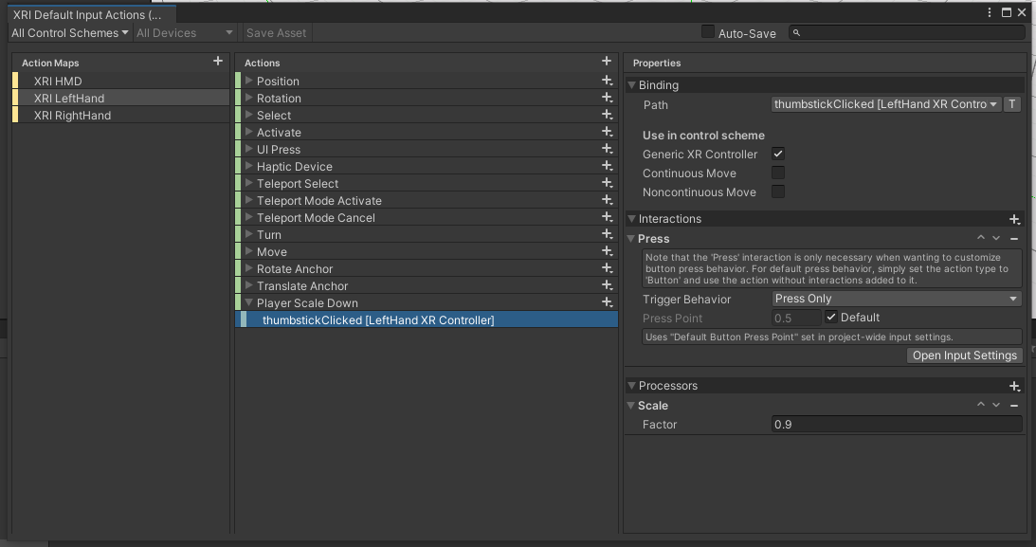
Scaling player
In the XRI Default Input Actions I added the Actions shown in Figure 12.
This was added for shrinking by 10% on left hand, and grow by 10% on right hand. It did not work, so I looked around for tips. Later I changed it to shrink on right hand and grow on left hand.
Figure 12 - Player Scale
On the XR Interaction Manager I added component Input manager, and in its list I added our XRI Default Input Actions.
Still nothing.
It seems most was incorrect. We remove the “Interactions” and “Processors” for the Player Scale Up and Down. I then watched this great video.
I add a Player.cs script to the XR Rig and add functions for scaling up and down there. This did not work initially, but in the end it did!
The control not the most intuitive perhaps, but it works. I didn’t use it, but this reference is very helpful.
Everytime the player clicks the left grip they grow by 10%, and shrink 10% for the right grip.
The Input actions were moved to a new Action map, to keep everything cleaner.
A function for showing/hiding symmetry was made, and bound to left thumbstick.
Lastly, I added sizing of atoms, using the grip buttons, and 10%.
These can and maybe should be rebound, and the scaling and sizing could be while holding down, allowing scaling to faster and easier for the player.

Building Game
In File I selected Build Settings. For PC, Mac & Linux Standalone I had the error Currently selected scripting backend (IL2CPP) is not installed. According to the web this was something I needed to add in the Installer in Unity Hub. As the error hindered me from pressing Build I went to Unity Hub and pressed Add Modules on the Unity Installation. There I selected Linux Build Support (IL2CPP) and
Windows Build Support (IL2CPP). The modules were added and I checked that the game still ran in Play Mode (it did).
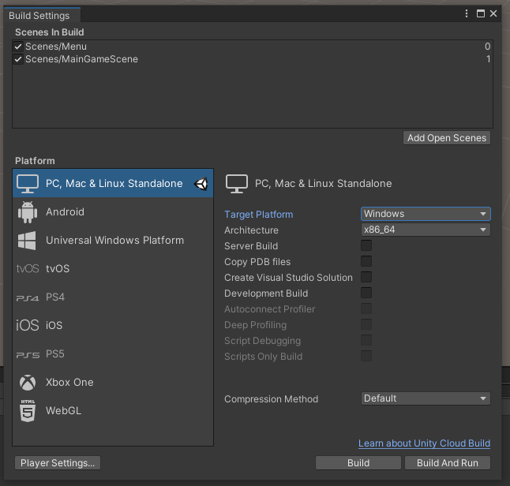
See Figure 13 for the Build Settings.
Figure 13 - Build Settings
Create Visual Studio Solution allegedly:
Generates Visual Studio files for the project, allowing to build the project from Visual Studio directly.
I didn’t want to fiddle with it incase it would break something, so I left it alone, and pressed Build, selecting an empty folder named “Build 20210824”.
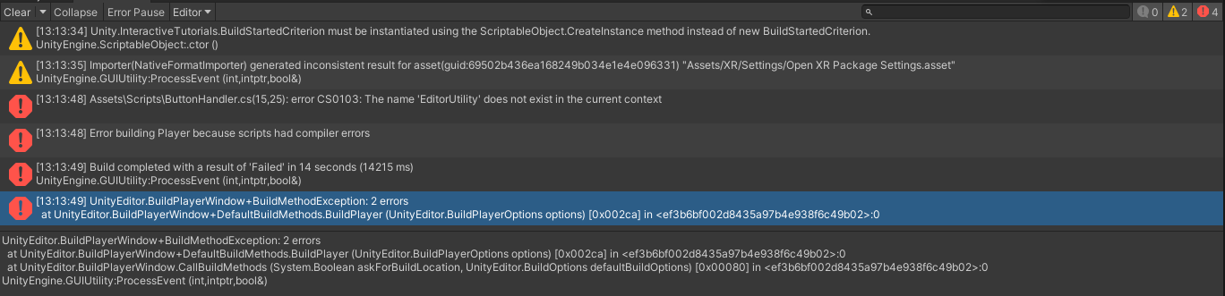
While building I got some errors and the process cancelled. The errors are shown in Figure 14. The second warning I have seen before, but it has never caused issues.
Figure 14 - Build Errors.
Error 1: EditorUtility is used for the FileDialogWindow. If this does not exist, we might need to introduce the runtime file dialog. This could be smart either way, as it supposedly works in VR. Reading the web it seemst the EditorUtility is part of the UnityEditor namespace, which is removed for built games, as the games aren’t meant to be ran in the Unity Editor. This forum suggests implementing it ourselves. This means we will transition into the Runtime File Dialog. The note in step 12 of Creating a user-menu for loading crystals talks about this.
The rest of the errors seem to be coming from the first one, so fixing the file dialog should fix everything.

File dialog
The file browser I am looking at installing is Runtime File Browser.
This one also looks promising: Unity Standalone File Browser, however, this is not an “in-game” UI, so that means the player still needs to remove their headset.
- On the website I log in and press Add to My Assets and accept the asset store terms.
I get a pop-up and select Open in Unity.
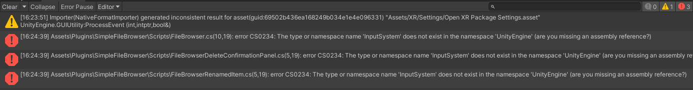
- In Unity’s package manager I browse for the Runtime File Browser and download version 1.4.7.
Then, I press Import. This brings up a directory of what I want to import. Everything was checked off, and I pressed Import.
I got some errors and those are shown in Figure 15.
The error is that UnityEngine.InputSystem does not exist. However, I am using that I in ButtonHandler.cs, and that works. The package manager shows it is installed with version 1.0.2. I have not imported the samples, but that should not be the issue.
Figure 15 - Runtime File Browser import errors.
- I looked at this forum post. In Preferences->External Tools and check off for generating .csproj files for Registry packages, and Regenerating project files. This did not resolve the issue, but I saw in the changelong that this was written:
Added new Input System support (requires manual modifications, see documentation)
The documentation was found in README in Assets/Plugins and had a small guide. Real documentation was in the asset’s GitHub. Parts of the guide was done during install, whereas others were needed. In the SimpleFileBrowser.Runtime.asmdef I added Unity.InputSystem to the list of Assembly Definition References.
Applying this removed all the errors, but more steps might be needed.
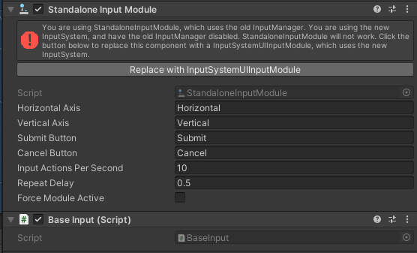
- After adding a simple Load Dialog, and testing it, I found it didn’t show the dialog window, so I continued with the documentation.
Figure 16 - SimpleFileBrowserCanvas prefab components for change from documentation.
  - I opened the SimpleFileBrowserCanvas prefab (it is in Plugins->SimpleFileBrowser->Resources), selected the EventSystem and replaced the StandaloneInputModule module with the InputSystemUIInputModule component. My scene already had an EventSystem, so I could have deleted the prefabs EventSystem instead, but I didn’t.
See Figure 16 for a picture of the prefab component in question. I pressed the Replace button that was under the error message.
The dialog still did not show up.
  - I tried deleting the EventSystem from the prefab, but that did not help. However, I could not crtl+z to get it back so it’s gone for now. (Should not be a problem as the Dialog is only used in the UI-menu, which already has an EventSystem).
  - I hadn’t put the command in a StartCoroutine() so that fixed it.
- I moved the old parts of the GetInfile() function into the Coroutine, and this did so that the filename was kept and worked.
- When in VR the File Browser does not show, likely due to the Render Mode of the canvas.
  - To fix this I placed the prefab from earlier into the Menu scene, and de-activated it through the Start() in ButtonHandler.cs.
This seems to work great.
- The VR player cannot, however, interact with the File Browser, so this needs to be fixed.
In addition the VR controller rays are transparent when looking at the File Browser.
  - I attempted to add a Tracked Device Graphic Raycaster component to the prefab in the scene, as that was on the UI Menu Canvas.
This made parts of the UI interactable, but not all of it.
  - The Files section of the FileBrowser was a Canvas without the raycaster we needed, so I added that.
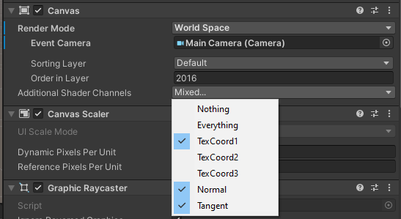
  - I also changed the Canvas’ canvas component to Order in Layer 0, and Additional Shader Channels Nothing. See Figure 17.
Figure 17 - SimpleFileBrowserCanvas Canvas Component.
  - Not sure If b) or c) fixed it, but both having been adjusted the File Browser works perfectly.

Building the project (again)
After changing the File Dialog I was ready to attempt a build again:
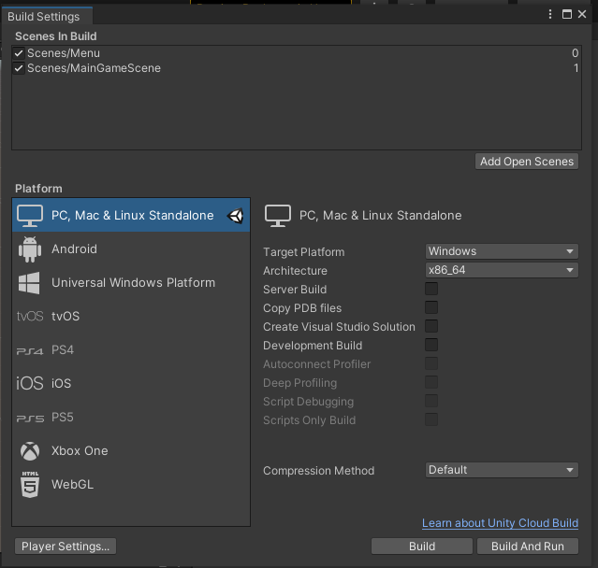
- I went to File->Build and chose PC, Mac and Linux Standalone. See Figure 18 for the settings. Note that both our two scences are marked.
pressing Build I needed to chose a folder, and I created an empty Folder named Build 20210825 2320.
Figure 18 - Build Settings
  - No error messages appeared, and after the build completed I got a folder pop-up as shown in Figure 19. Meanwhile the Unity console gave 4 warnings and a message of a successful build! See figure 20.
- I connected the headset and attempted to run the built .exe. The game ran, but it did not connect to SteamVR and show up in the headset.
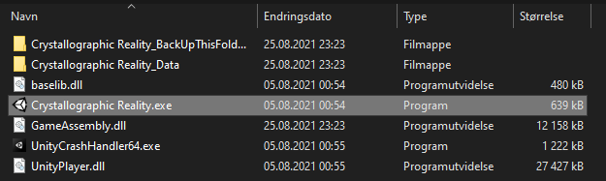
- I opened steam and added the game as a non-Steam game. This is in Steam’s Games tab.
This did not help. However, this reminded me that the game does not have a picture! That can be adjusted in a later build.
Figure 19 - Build Folder
- I added it to Oculus, but that also did not help.
- Lastly, I went into SteamVR->Settings->Show Advanced->Developer and set SteamVR as the OpenXR runtime. This made the game load in VR!
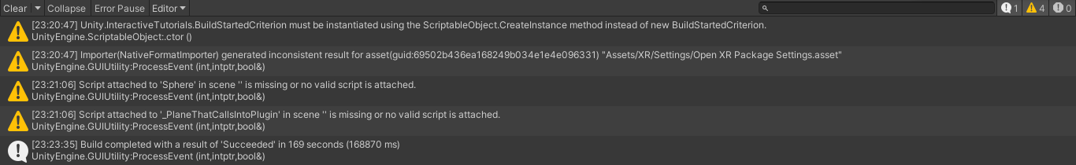
  - The game loads. However, after selecting a file and pressing Launch nothing happens. I would guess this is related to switching scences. However, I did attempt a .cif-file I had not read before, so it could have been that the game could not find the converted .txt. Looking in the Player.log (Appdata->LocalLow->UiO TeamVR->Crystallographic Reality) we see the error is in the function TestSetup() in Crystalmanager.cs. See the error here:
Win32Exception: mono-io-layer-error (0)
at System.Diagnostics.Process.StartWithShellExecuteEx (System.Diagnostics.ProcessStartInfo startInfo) [0x00000] in <00000000000000000000000000000000>:0
at CrystalManager.TestSetup () [0x00000] in <00000000000000000000000000000000>:0
at …
TestSetup() is the first time the game encounters The System.Diagnostics.Process where whe run our command. This is crucial for runtime conversion of .cif-files.
Figure 20 - Build process warnings.
  - Running the game as administrator did not fix the issue.
Looking around the issue is that Process.Start (the function which runs the command) does not work with IL2CPP, as Unity has not added the .NET Process class in IL2CPP “yet”. See forum post here. This issue occurred in May 2018, but has not been fixed
Someone asked again on Jul21, and the developer that answered in 2018 said it likely will not be implemented
  - One fix is to change the scripting backend from IL2CPP to Mono. Info can be found on them here.
    - IL2CPP compiles the entire application before it is run.
    - Mono compiles the code as it is needed during runtime.
It seems like IL2CPP is the superior choice as compiling code during runtime sounds slow and heavy on the system.
  - Another fix is to change the Process to use this GitHub-fix someone made: IL2cppStartProcess. This is likely the better option, should the game work slowly, however I do not have time (I have passed my hours) so I will switch to Mono.
- In Unity->Project Settings->Other Settings->Configuration I changed the Scripting Backend from IL2CPP to Mono, then built the game again.
The build-time went from 160 seconds with IL2CPP to 25 seconds with Mono. I fear this means those seconds will pay us back each time the game is run.
- The game built successfully, it ran successfully, chose files successfully, and the external processes worked successfully. It is done. It is complete, and it is beautiful.

